**Performance Testing Using JMETER.**

**Test 1 ->**

* **833 users for 300 sec**
* 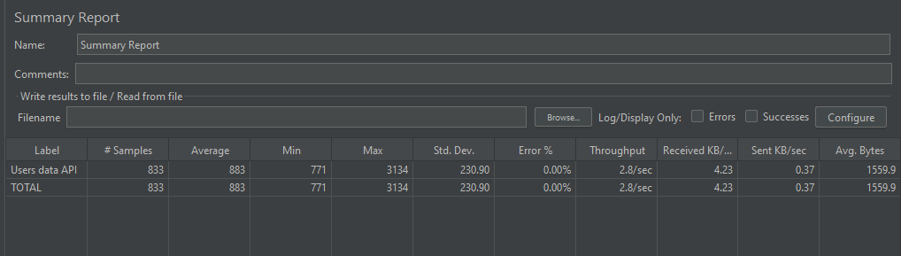**Throughput: 2.7 sec**

***fig 1: testing 833 users for 300s.***

**Test 2->**

* **1666 users for 600 sec**
* **Throughput: 2.8 sec**

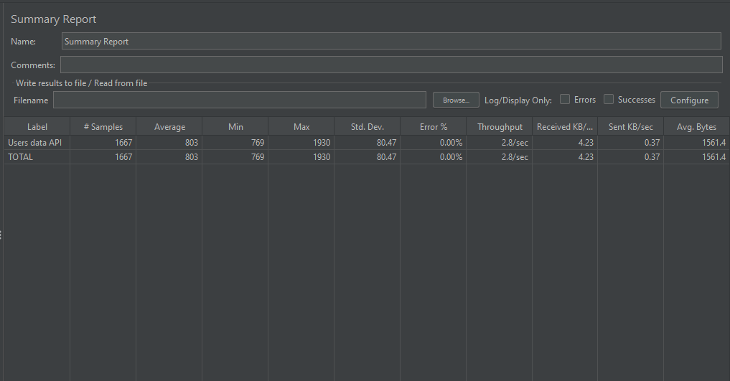

***fig 2: testing 1666 users for 600s***